Assignment #2: 语法练习

1. 题目

263A. Beautiful Matrix

<https://codeforces.com/problemset/problem/263/A>

**代码：**

for i in range(5):  
 a = input().split()  
 if "1" in a:  
 print(abs(i-2) + abs(a.index("1")-2))  
 break

**截图：**

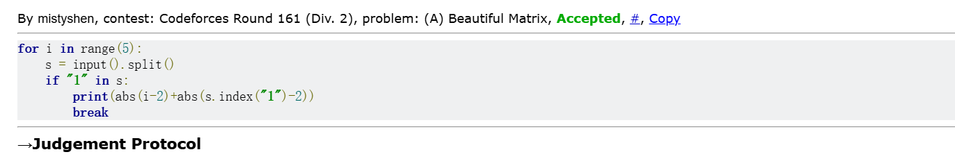

1328A. Divisibility Problem

<https://codeforces.com/problemset/problem/1328/A>

**代码：**

n = int(input())  
for i in range(n):  
 a,b = map(int,input().split())  
 output = a % b  
 if output == 0:  
 print(0)  
 else:  
 print(b - output)

**截图：**

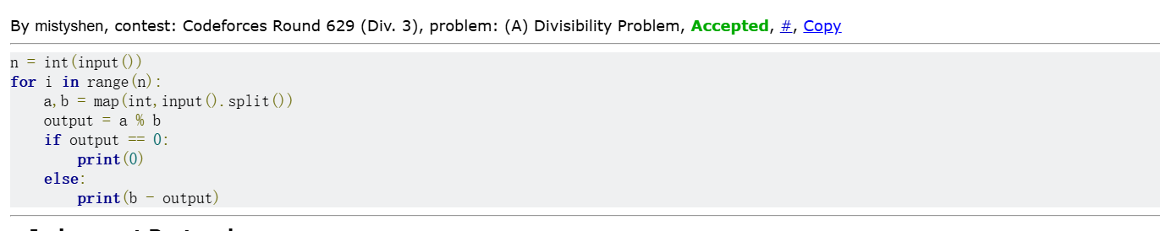

427A. Police Recruits

<https://codeforces.com/problemset/problem/427/A>

**代码：**

n = int(input())a = list(map(int, input().split()))cnt = 0officers = 0for i in a:

if i == -1 and officers == 0:

cnt += 1

continue

if i > 0:

officers += i

continue

officers -= 1

print(cnt)

**截图：**

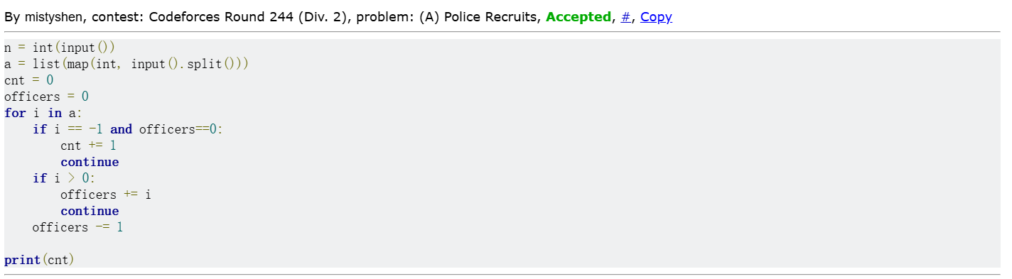

02808: 校门外的树

<http://cs101.openjudge.cn/practice/02808/>

**代码：**

L, m = map(int, input().split())  
  
dp = [1]*(L+1)  
  
for i in range(m):  
 s, e = map(int, input().split())  
 for j in range(s, e+1):  
 dp[j] = 0  
  
print(dp.count(1))

**截图：**

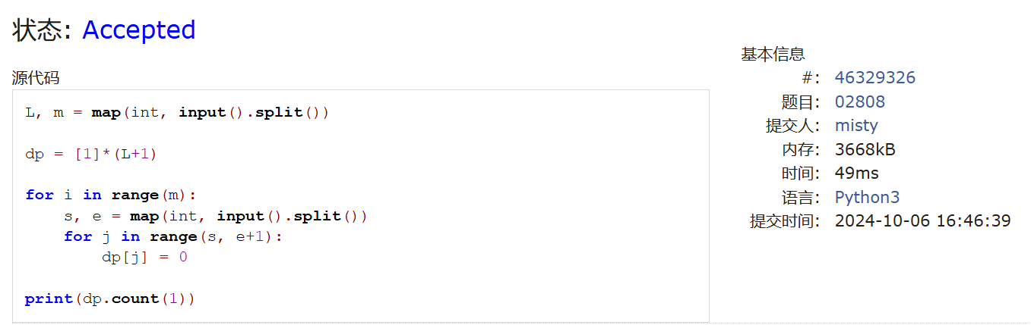

sy60: 水仙花数II

<https://sunnywhy.com/sfbj/3/1/60>

**代码：**

def find_narcissistic_numbers(a, b):

    result = []

    for n in range(a, b + 1):

        hundreds = n // 100

        tens = (n % 100) // 10

        units = n % 10

        if hundreds**3 + tens**3 + units**3 == n:

            result.append(n)

    if result:

        print(" ".join(map(str, result)))

    else:

        print("NO")

a, b = map(int, input().split())

find_narcissistic_numbers(a, b)

**截图：**

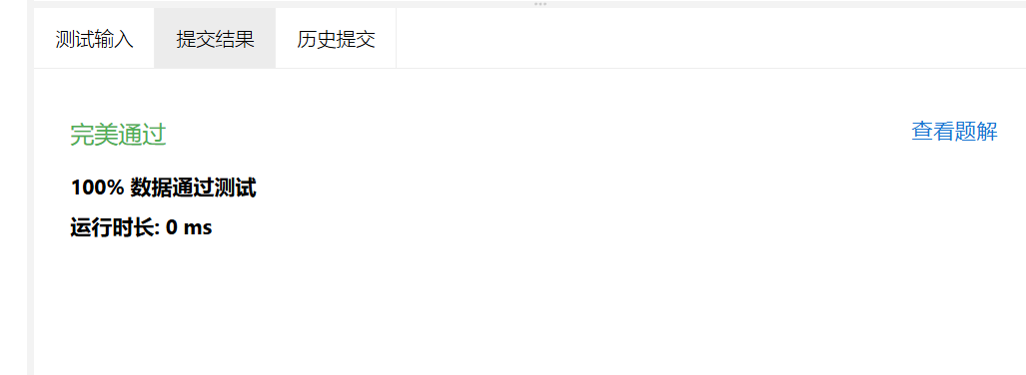

01922: Ride to School

<http://cs101.openjudge.cn/practice/01922/>

**代码：**

import math  
  
while True:  
 n = int(input())  
 if n == 0:  
 break  
  
 max_time = float("inf")  
 for _ in range(n):  
 speed, time = map(int, input().split())  
 if time < 0:  
 continue  
 arrival_time = math.ceil((4500 / speed) * 3.6 + time)  
 max_time = min(max_time, arrival_time)  
  
 print(max_time)

**截图：**

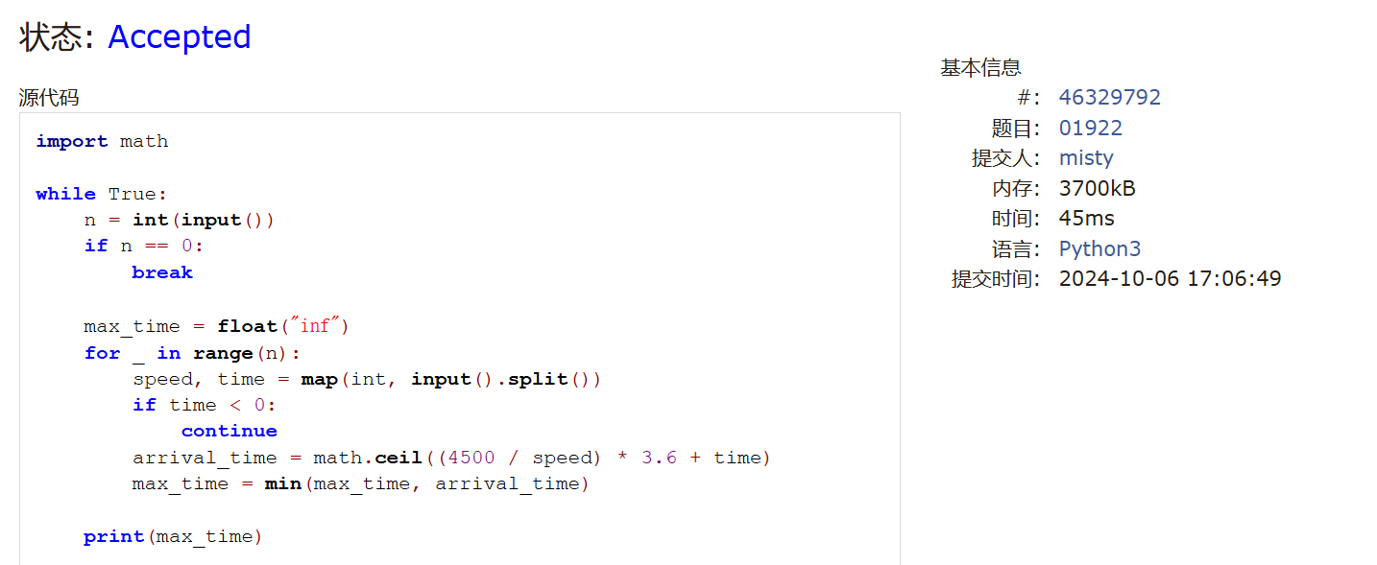

1. 学习总结和收获
2. 第一次见到动态规划
3. 涉及到很多数字计算，注意到做题时运算符号容易写错
4. 题目感觉比上次难，但是难度提升不大，这样的节奏还可以接受